### A Rocking Horse Favor Box That Really Rocks

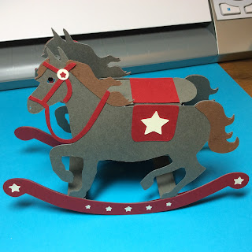

I love rocking horses. My Auntie Arax bought a red and black horse for my brother when he was little. As a child, I enjoyed playing on the horse with its rocking motion. I recreated this sensation with this paper rocking horse. It moves back and forth with very little effort.

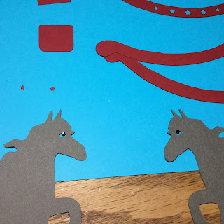

Glue on the black eyes on each side of the horse.

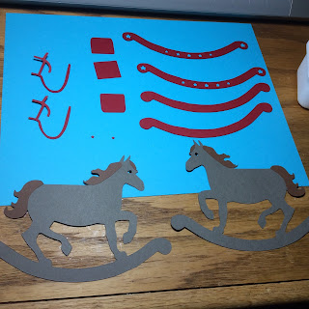

Glue on the tail, mane and hair by the eyes.

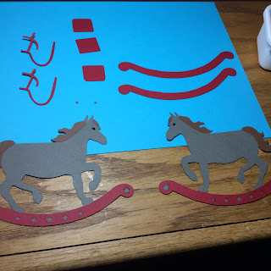

Glue the star rocker to the outside of the horse.

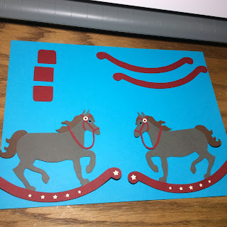

Glue on the bridle and add the beige circle and star.

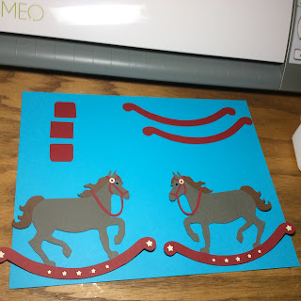

Glue the beige stars to the rocker.

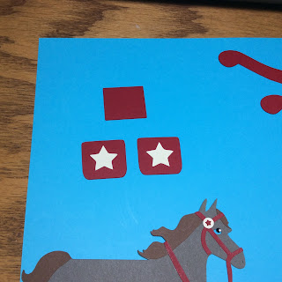

Glue on the beige stars to the saddle.

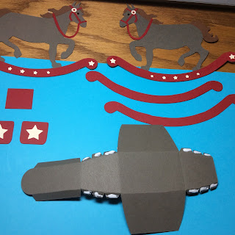

Make the saddle box by folding the box and putting glue on the six tabs as shown.

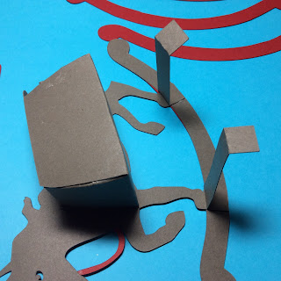

Attach the rocker support and one side of the saddle box to the horse. Make sure the saddle box can be opened from the back position.

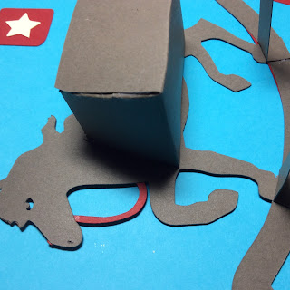

Alignment photo of saddle box.

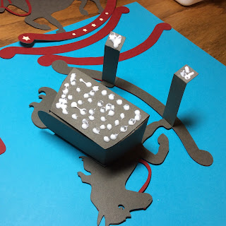

Glue on the other side of the horse to complete the figure.

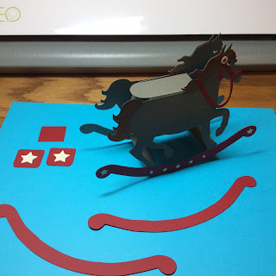

Completed rocking horse without the inside rocker or saddle bags.

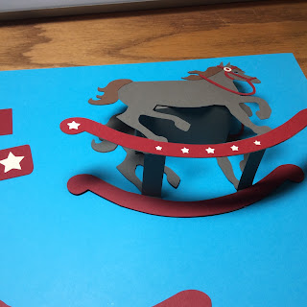

Glue on the inside rocker to both sides.

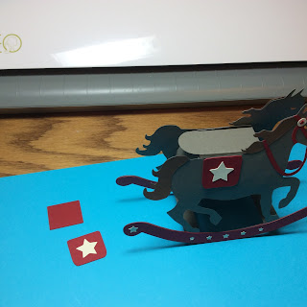

Glue and align the saddle bags. Start on one side with the star.

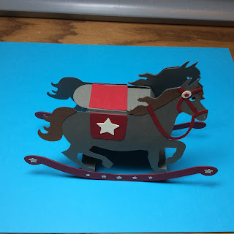

Add the top saddle piece (square piece) and then the other star saddle piece to complete the rocking horse.

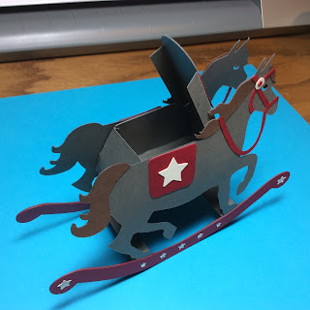

Box in open position.

I hope you enjoy making this rocking horse. It is truly amazing to see it rock!